Taking Business Architecture to the Next Level: Establishing a Foundation for Success

Introduction
Many organizations recognize significant value is to be gained by adopting business architecture principles. Yet, many organizations that have adopted business architecture are still in early stages of doing so. Practitioners report barriers to realizing benefits that include both an inability to communicate its essence and value, and then having done so, scale business architecture to a point where benefits can be sustained across projects, teams, and business units.

There are many alternative means of capturing and leveraging a business architecture. Tools often used include documents, presentations, diagrams and spread sheets. However, these desktop-oriented options result in limited scalability and as a result constrain the deployment and success of initiatives attempting to leverage business architecture.

Establishing a foundation for business architecture that consistently captures and represents domains and concepts allows the use of business architecture to scale across an ecosystem. In addition, having a consistent, foundational means of representing a business architecture opens the way for common reference models to be applied that can save months of mapping and related startup efforts. Taking a more uniform approach then allows multiple initiatives to be undertaken and the benefits to cascade throughout the organization.

Application of a uniform approach can benefit from the use of software tools that directly support a shared approach to representing business architecture concepts. Tools that leverage a consistent, widely accepted approach to representing a business architecture allow organizations to accelerate the capture and communication of shared domains and concepts and assist with demonstrating the essence and overall value proposition.

The Business Architecture Core Metamodel (BACM) is a standardization effort that seeks to establish a formal foundation for business architecture principles and best practices, furthering enabling the adoption of the discipline, reference model deployment, scalability, and automation support to enable the capture, communication, and interchange of essential business perspectives.

Standardizing a core metamodel establishes a foundation that is essential to taking the value proposition of business architecture to the next level, scaling the discipline across business ecosystems and delivering benefits across a variety of related disciplines, business areas, and strategic initiatives.

Shifting Silo-oriented Thinking to Ecosystem-oriented Thinking
Modern organizations do not start or stop at their legal boundaries. Businesses no longer operate in silos, but rather, are part of a larger ecosystem. Awareness of relevant stakeholders and the ways in which they support the value delivery of a business is key to innovation and overall success.

Increasingly, businesses need to adapt to meet the needs of customers. A rapidly changing world requires undertaking new initiatives, along with business transformation, in order to drive innovation so as to compete better with others. An ecosystem wide view of a business enables innovation and transformation from a more holistic perspective that a comprehensive mapping of an organization’s business architecture delivers.

A comprehensive, end-to-end view of one’s business architecture drives innovative thinking and transformative investments from ideation through realization, enabling multiple disciplines along the way. Consider that agile approaches can help to meet needs quickly, but unless the right customer needs are identified and strategy aligned with this, how can you know investment decisions are well informed?

Acting and decision making become very risky in complex environments without a comprehensive view of the affected business ecosystem. The ability to anticipate problems before they occur can mitigate risk of losing investments downstream because of a lack of foresight upstream. A comprehensive view of one’s ecosystem using business architecture surfaces issues early on and helps prioritize investments for optimal solutions.

Business architecture tackles this issue by providing means to capture the complete business ecosystem and its value-focused components. As a result, the business and its environment are broken down into understandable and manageable pieces that are focused on adding value to customers.

Business architecture enables innovation, transformation, and successful solution deployments by providing a framework for establishing an abstract representation of an organizations that enables translate practitioners to interpret strategic objectives and demands and drive them into precise courses of actions.

While a generalize approach to business architecture has been established and in use by organizations worldwide, different methodologies and conventions have arisen across various industries. For example, organizations and consultants have developed their own methods for business architecture. These approaches may be mostly self-consistent, the perspectives deployed tend to lack a complete business architecture perspective that can be leveraged and maintained across a business or multiple organizations in a consistent, implementable manner.

The Object Management Group (OMG) recognized the need to create a business architecture standard and has paved the way towards standardization by requesting various organizations to develop proposals to establish a metamodel that represents universally shared framework of business architecture. The BACM is the result of this request for proposal as represented by the Business Architecture Guild.

Common Understanding
Variation in human thought, behavior, and opinion is understood and accepted by most. Frequent frustration between individuals because of misunderstanding arise from many root causes. A lack of shared vocabulary and/or weak understanding of concepts core to the conversation may be to blame. Personal biases and lenses are driven by experience, current environment and maturity of thought around what constitutes value. Without common ground, these biases can become debilitating and stifle the output of a well-meaning and otherwise high-performing team.

Business architecture must have the capacity to establish a holistic frame of reference from customer need, through strategy realization and down to operational deployment. Business architecture must have the capacity to effectively represent a business ecosystem, which is defined as “one or more legal entities, in whole or in part, that exist as an integrated community of individuals and assets, or aggregations thereof, interacting as a cohesive whole toward a common mission or purpose.” The scope of business architecture is framed by fundamental business architecture focal points or “domains”. These domains form the basic building blocks of business architecture and provide the basis for establishing a wide variety of business abstractions that enable business ecosystem transparency.

Figure 1 depicts the four core business architecture domains and five extended domains and metrics perspective on a business. Core domains define what a business does using capability, information and related vocabulary, end-to-end stakeholder value delivery using value streams, and business structure and partner engagement via the organization view. Extended domains represent the cross-section of business stakeholders, including customers who are the recipients of business value, strategies and policies that drive actions to be taken, products delivered to the end customer, and initiatives that are the target of business investments. Business performance metrics provide a basis for planning, investments, and deployment option analysis.

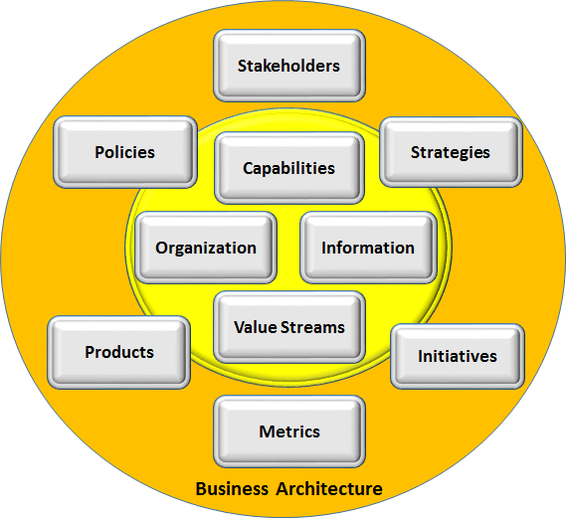Source: BIZBOK® Guide
Figure 1: Core and Extended Business Architecture Domains

While having a common vocabulary for the terms defined in figure 1 simplifies communication of the essence of business architecture, simply using the same terms in a discussion will not guarantee a common understanding. It is the meaning of those terms and underlying concepts that must align. Without a common understanding of underlying concepts there is a risk that terms will be misunderstood, resulting in frustration and dysfunction.
Fortunately, the Business Architecture Guild has established a business architecture framework, glossary of terms, and detailed principles, practices, and guidelines to guide professionals exercising the discipline. The principles, practices, and guidelines detailed in A Guide to the Business Architecture Body of Knowledge® (BIZBOK® Guide) are based on a widely deployed approach by a global community of practice. Formalizing this approach in an industry standard representation that enables tool providers to represent and exchange business architecture metadata is the logical next step, to be realized in the BACM.

Information Concepts
Business architecture seeks to map perspectives of the business. These perspectives are originally conceptual in nature because they exist in the mind of practitioners, who translate their understanding into an information map. The objects they identify include both tangible and intangible objects, and when documented are mapped as information concepts.
The term "business object" is often used to denote things that are important to a business and are acted upon by the business, without distinguishing whether they are tangible or intangible. Business objects are an important part of an information map because these concepts help identify capabilities and they are also related to many other elements in business architecture maps.

Information maps are particularly important because they help establish a common vocabulary and can also help highlight relationships between concepts that may otherwise be overlooked. In some cases, the relationships identified are important concepts and not simply a connection.

For example Customers and Products of a software organization, when customers buy a product what capabilities of an organization are needed to enable this to happen? At first you may consider a customer simply to buy a product, and therefore you would need capabilities around customer and product to fulfil this, right? Yet on closer analysis a customer of software may be purchasing a subscription, which involves entering into an agreement to use a product for a period of time. The existence of an agreement will also bring with it obligations for the organization. The existence of an agreement and terms are key pieces of information that help clarify the business model, value stream and needed capabilities to support this.

Scaling Business Architecture
For business architecture to be useful it needs to encompass the key value streams that identify how customers attain value from an organization and the capabilities that support this value delivery. Stakeholders would need to be engaged, information leveraged, and products and related value propositions delivered as a result. These and related business perspectives including strategy, policy, and initiatives must be interwoven in specific ways to establish a functioning business architecture.

In general practice, a small team of people capture information in a consistent, principled manner using a range of tools and technologies. For example, Excel is often used to capture capabilities, information, organization, and related domains. Visualization or mappings are often captured in simple Visio diagrams. However, as the number domains and relationships among those domains increases, the discipline required to keep this information consistent, up-to-date, and accessible also increases.

At some point it becomes a futile effort because:

- There is redundant data across the various mappings
- People update them inconsistently or in an uncoordinated manner
- There is no cross-validation, synchronization, and consistent versioning
- The overall reliability and usefulness of the business architecture becomes suspect as it increases in size
- It becomes increasingly difficult to coordinate releases to people across the business

Essentially, for an organization to successfully mature a business architecture and its use on multiple scenarios and initiatives across a business ecosystem requires automation that is based on a consistent perspective that aligns to industry best practices and principle. In other words,

better tool support is needed that adheres to an approach that is based on the principled approach outlined in the BIZBOK® Guide.

Business Architecture Core Metamodel
Optimizing business architecture’s value proposition requires a consistent representative perspective. The BACM establishes a way to formalize the concepts embodied in the global body of practice by way of a “metamodel”. The metamodel is the underlying technical foundation for representing

the business architecture as defined by the aforementioned domain structure and overall framework. Figure 2 depicts a high-level view of the business architecture metamodel underlying the business architecture domains and body of practice.

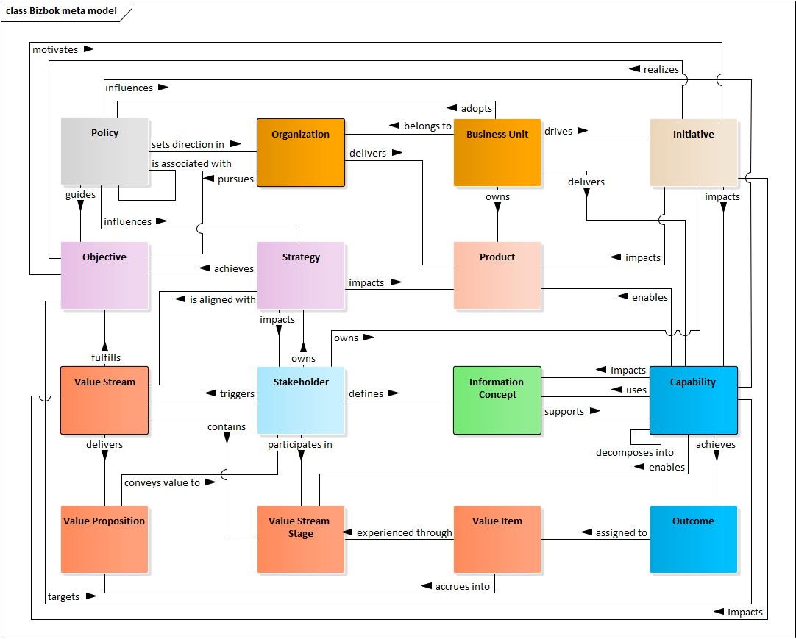
Figure 2: Business Architecture Summary Level Metamodel
The representation shown in figure 1 is a high-level perspective that highlights relationships among core and extended domains and selective critical elements such as capability outcome, value item, and value proposition. One or more detailed metamodel packages exist for each domain category shown in figure 2. The collective set of packages along with an overall package that binds all packages is currently under consideration to be standardized as the BACM.

The BACM has the following characteristics:

- Ensures that the business architecture is consistent and enables more effective management of business complexities
- Enables visualization of the business architecture at a level of abstraction appropriate for the understanding and analysis of business executives, planners, practitioners, and deployment teams
- Aligns to best practices and principles as articulated by BIZBOK® Guide
- Enables the exchange of models among different modeling tools to avoid vendor lock-in and promote competition for quality and continued improvement of modeling tools.
- Provides consistent modeling techniques and methods to advance the discipline and support the training and certification of business architecture professionals.
- Facilitates the integration of interdisciplinary business models, whether based on OMG standards, related standards or other adopted business perspectives

Note that the BACM does not veer into what would be considered “instances” of a business architecture because doing so would constrain an organization’s ability to frame and leverage capability and related business architecture domain mappings unique to a given business model or models. For example, a transportation company would define assets, routes, conveyers, locations, and other business object-based perspectives in its business architecture. These business objects form the basis for capabilities, defined in a capability map, and information concepts, defined in an information map.
Ensuring that the BACM does not veer into specific industry sectors means that the same standardized approach works for a commercial company with customers, a hospital with patients, or a federal government agency with constituents. The BACM metamodel must accommodate any business architecture represented for any business ecosystem regardless of industry sector or geographic region.

Accelerating Adoption
Understanding how to perform this consistently and with a sufficient scope is important to accelerate adoption and resulting benefits. Tools are one aspect of this. Having clear examples of an industry, as well as having application of principles is also important.
While the BACM does not incorporate specific industry sectors, representing a given industry is addressed using industry reference model. A multitude of specific industry sectors and subsectors may be addressed via industry reference models. Reference models:
- Can fast track an organization capturing their own business architecture.
- Embody a principled approach and serve as a good example
- Capturing and presenting concepts consistently requires consistent definitions of concepts and rules as to how they can be captured and presented
- Doesn’t mean all details need to be captures from an enterprise architecture – the business architecture concepts are the bridge for this

Conclusion
Business architecture transcend business unit silos in order to visualize and understand the larger business ecosystem. To support this holistic approach to business architecture and scale it accordingly, organizations must seek a level of formality supported by industry standards and related technologies that align to these standards.

The Business Architecture Core Metamodel (BACM) is a standardization effort that seeks to establish a formal foundation for business architecture principles and best practices, furthering enabling the adoption of the discipline, reference model deployment, scalability, and automation support to enable the capture, communication, and interchange of essential business perspectives.

Establishing this foundation is essential to taking the value proposition of business architecture to the next level, scaling it across business ecosystems and delivering benefits across a variety of related disciplines, business areas, and strategic initiatives.

Note to Readers:
The BACM is undergoing standards submission reviews into 2019. As the OMG moves it process forward, it is anticipated that the BACM will reach the point where it becomes an adopted standard in over the course of 2019. This paper will be updated according as progress ensues.

A Guide to the Business Architecture Body of Knowledge® (BIZBOK® Guide), v7.0, Part 1
A Guide to the Business Architecture Body of Knowledge® (BIZBOK® Guide), v7.0, Part 1
A Guide to the Business Architecture Body of Knowledge® (BIZBOK® Guide), v7.0, Section 5.1.

